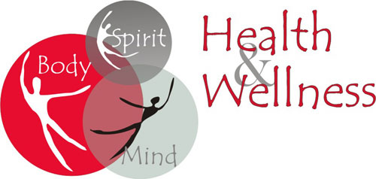
DMX DANCE MOTION XPLOSION Studio
23020 Power Rd Farmington
ADULT WORKOUT CLASSES
- STRETCH
- ZUMBA DANCE
EVERY WEDNESDAY
6:00 – 7:00 PM
(STARTING 7/22)
JOIN US FOR A COMPLETE WORKOUT $25.00 PER MONTH
